

**Placement Empowerment Program**

***Cloud Computing and DevOps Centre***

***Implement Auto-scaling in the Cloud :*** *Set up an auto-scaling group for your cloud VMs to handle variable workloads.*

**Name: VIJAYA NANDANA M Department: CSE**

**Introduction**

Auto Scaling in AWS is a powerful feature that automatically adjusts the number of EC2 instances in response to traffic demand. This ensures high availability, cost efficiency, and optimal performance. By defining a Launch Template, creating an Auto Scaling Group (ASG), and setting up scaling policies, we can dynamically scale instances based on CPU utilization or other metrics.

**Objectives**

* Create a Launch Template to define the configuration for EC2 instances.
* Set up an Auto Scaling Group (ASG) to manage instance scaling.
* Define Scaling Policies to automatically increase or decrease instances based on CPU utilization.
* Test Auto Scaling by simulating high CPU usage and verifying instance scaling.

**Step by Step Overview**

**1. Create an EC2 instance**

- log into your aws account.

- create an EC2 instance.

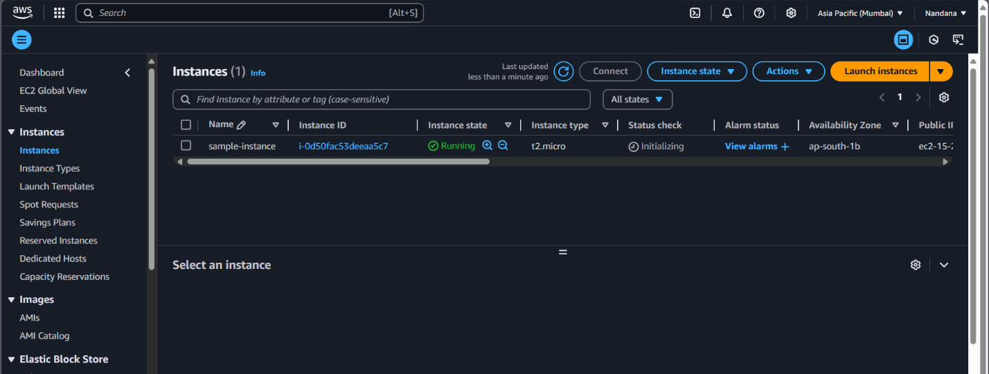

**2. Create Launch Template**

• In the left panel, click on Launch Templates

• Click Create Launch Template

• Enter a name (e.g., MyLaunchTemplate)

• Select an AMI (Amazon Machine Image)

* Choose a relevant Linux or Windows AMI

• Choose an Instance Type (e.g., t2.micro)

• Choose an IAM Role (if required)

• Add Key Pair for SSH access

• Add Security Groups (allow SSH & required ports)



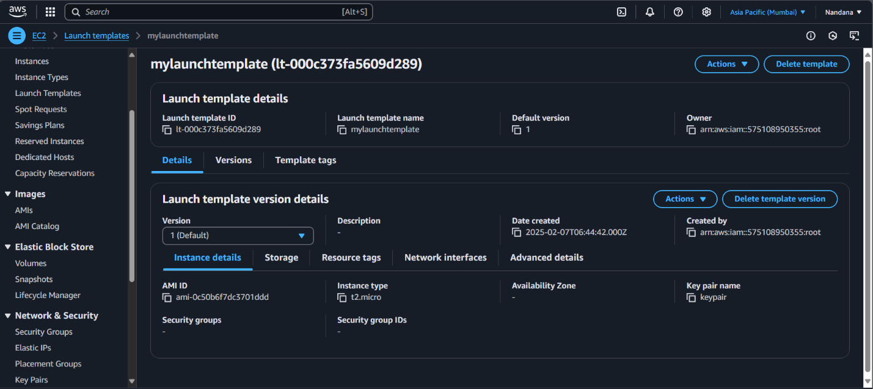

### **3. Create Auto Scaling Group**

* In the EC2 Dashboard, click Auto Scaling Groups
* Click Create Auto Scaling Group
* **Select the Launch Template**
* Choose the Launch Template created earlier

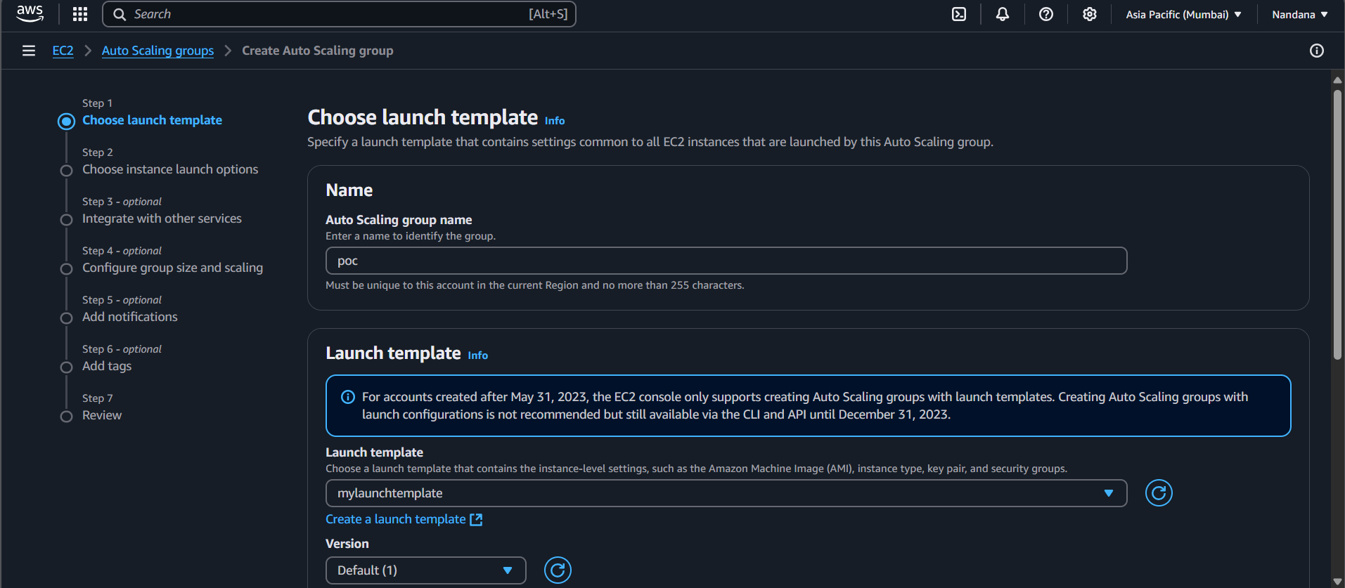

* **Configure the Auto Scaling Group**
* Set Auto Scaling Group Name (e.g., MyAutoScalingGroup)
* Select VPC & Subnets
* Click Next
* **Set Desired Capacity & Scaling**
* Desired Capacity: 1
* Minimum Instances: 1
* Maximum Instances: 5
* Click Next
* **Configure Health Checks & Load Balancing (optional)**
* Enable ELB (optional)
* Enable Health Checks
* Click Create Auto Scaling Group

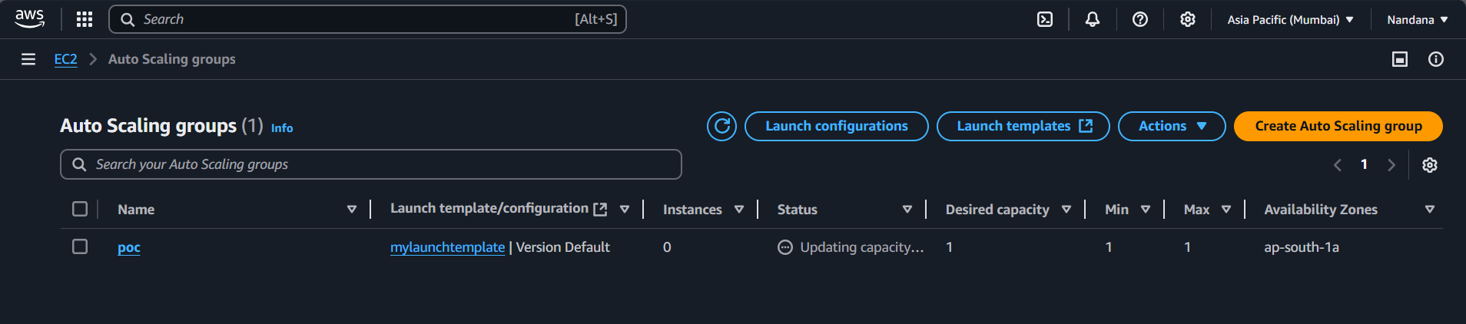

**4. Create Scaling Policy**

- Go to Automatic scaling and create scaling policy.

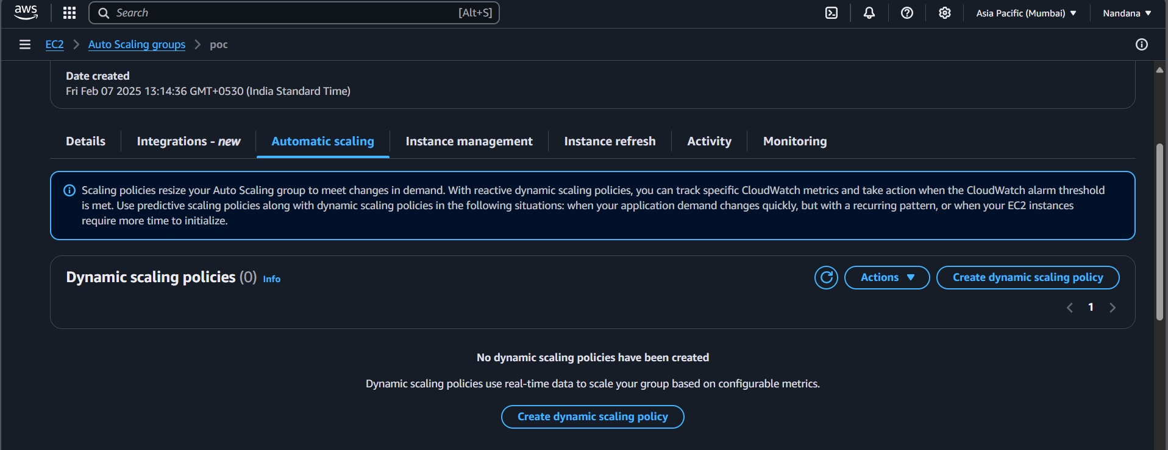

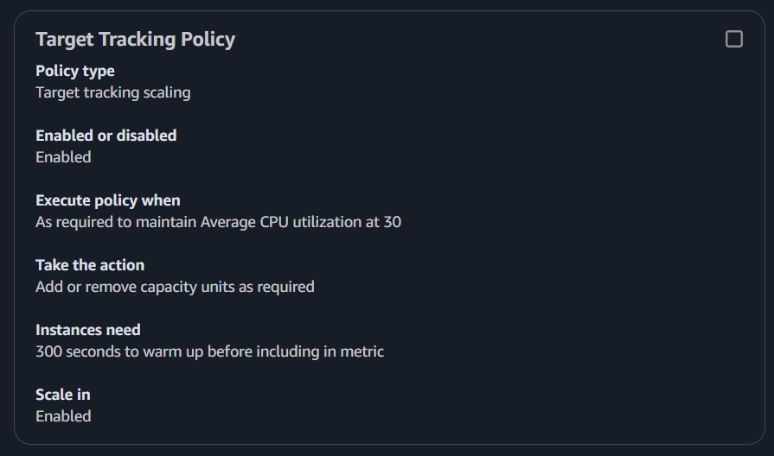

**5. Simulate High CPU Usage**

SSH into your system through command prompt. And then simulate stress.



**6. Monitor Scaling Events**

* Go to Auto Scaling Groups
* Click on Activity to check scaling actions

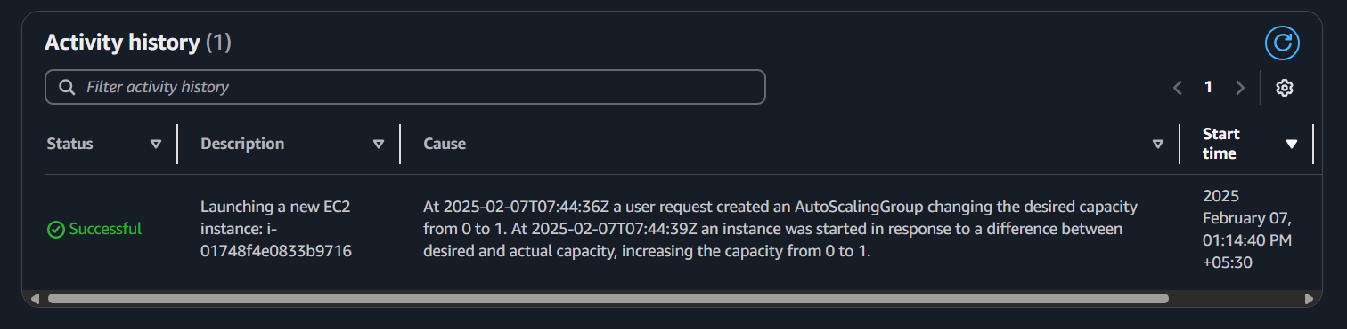

**Outcome:**

* A Launch Template configured with an EC2 instance setup.
* An Auto Scaling Group (ASG) that ensures automatic instance scaling.
* Scaling policies that trigger new instance launches or terminations based on CPU usage.
* Successfully tested Auto Scaling by generating high CPU load and observing instance scaling in real time.